Oral Disease Detection Using Multimodal Fusion
Abhishek A Joshi¹, Vasudhaika S², Sinchana Chindi³, Kaushik Mallibhat⁴ and Satish Chikkamath⁵
School of Electronics and Communication Engineering,
KLE Technological University, Hubballi, India
¹abhijoshi5301@gmail.com, ²vasudhaikareddy@gmail.com, ³sinchanachindi@gmail.com, ⁴kaushik@kletech.ac.in, ⁵chikkamath@kletech.ac.in
Abstract. The proposed work aims to present a novel framework to classify the oral diseases through multimodal data consisting of images and symptoms. The outcome of the work helps towards early diagnosis of oral diseases. Oral diseases are neglected by most people in the initial stages due to lack of awareness, accessibility, and availability of dental care. Early diagnosis of oral disease is necessary, and early research focused on either the image of the affected area or just the textual description (symptom) to predict the illness; both are essential. The study employs multimodal approach and utilizes an image dataset comprising seven categories of affected areas, sourced from Kaggle. Additionally, a textual symptoms dataset was developed, consisting of 150 combinations for each illness. Confidence scores of both the model (image-classifier model and symptom-based illness prediction model) with the true label, a new dataset is generated and it is trained with logistic regression to get the final predicted class. Image classifier model achieved 81% of accuracy whereas symptom-based model 97%, resulting in final multimodal accuracy of surpassing both the model accuracies.
Keywords: Oral disease, Image classification, Text input-based illness prediction, Multi-modal, Decision level fusion, Healthcare.
- Introduction
Around 3.5 billion people worldwide were affected by oral diseases in 2019, which is approximately 50% of the global population. The number of people affected by oral diseases is high compared to other diseases. People of different age groups suffer from different oral diseases. While dental caries is prevalent in all age groups, periodontal diseases is more common among older adults. Oral cancer stands out as the most severe and unpredictable oral condition, potentially resulting in fatalities if not properly addressed and treated.
Many individuals affected by oral diseases naturally tend to visit dentist when the pain is intolerable believing that the problem resolves with time. Some oral problems need immediate attention, but few people lack the financial means or awareness to receive an accurate diagnosis, leading to long term complications. News organizations have brought attention to the impact of dental-care accessibility issues. For example, the BBC Health article “Mouth-cancer Deaths Fear over NHS Dentist Shortage” discussed how delayed diagnoses of oral cancer led to lower survival rates. Almost everyone suffers from oral diseases once in their lifetime irrespective of their age and severity. However, early prediction of these conditions can enable timely treatment initiation or, if needed, consultation with a dentist.
Many attempts have been made to address the issue, but few models lack multimodal inputs, and a few others have dataset constraints. The idea proposed by the authors is to develop a multiclass classifier that detects oral diseases using a multimodal approach. The system receives user-provided textual inputs for the symptoms and visual inputs for the affected area. The decision-level fusion method was used to combine the outcomes of both modalities. The multiple classes include gingivitis, hypodontia, oral cancer, mouth ulcers, caries, tooth discoloration, and calculus.
The paper's subsequent part, Section 2, consists of a detailed review and literature survey of related works in oral disease. Section 3 provides the methodology, including data collection and the proposed work. Section 4 presents the results, analysis, and performance evaluation metrics. Finally, Section 5 concludes the paper with a summary and suggestions for future work followed by references.
- Related Work
The research papers considered are related to healthcare AI models that focus on image classification and text input disease classifiers. Research also included the papers with decision level fusion models. All these papers were studied to propose a solution for the problem.
The authors in [1] used Mask R-CNN for oral disease detection and segmentation. They concentrated on cold-canker sores, and because the dataset was not available, they used 40 photos from Google. Using 30 training images and 10 testing images, the authors demonstrated the effectiveness of the MASK-R-CNN model on a short dataset. After training the model with 20 images, the average confidence score of the test images was 70%. Therefore, although they employed the MASK-R-CNN approach, the dataset was the primary disadvantage of their model.
The authors in [6] presented a method which estimated visibility levels in winter CCTV images using logistic regression-based decision-level fusion. The study focuses on decision level fusion where the outcomes of the two SVM’s are getting fused using LR-based late fusion. A total of 540 photos from each of the three visibility levels were used for training and 60 photos were used for testing. The work described how decision level fusion improved the performance of the model.
The work [10] applied U-Net for identifying common oral disease lesions using 6,498 training and 722 testing images of common oral illnesses such as dental calculus, gingivitis, and decaying teeth with a VGG16 backbone. With an average mIoU of 50.41% and mAP of 63.11%, the model exceeded PSPNet and DeepLabV3, proving its usefulness in easing physician workloads and promoting self-diagnosis. The study is constrained by hardware limitations and dataset size, which have an impact on training speed and scalability.
The work [11] developed a neural network-based multimodal device for detecting oral diseases like oral cancer, periodontal disease, tooth erosion, and gingivitis. It employs sensors to measure parameters (e.g., pH and CO₂), transmitting data via Arduino to a cloud-based dataset classified by a CNN model with 91% accuracy. The device provides portable real-time monitoring and supports early diagnosis. However, its limitations include a small dataset (training: 200x4, testing: 50x4) and restricted disease categories (four classes); it also requires sensors, making it unsuitable for use by the public.
The work [12] utilized transfer learning for oral disease image detection which serves as the base paper for the study. Their approach introduced an AI-based system using transfer learning with MobileNetV2 to detect seven oral diseases, achieving 80% validation accuracy on an average. But the paper was constrained by its reliance on visual input alone, ignoring the symptoms faced by patients, limiting its ability to accurately diagnose all diseases.
- Proposed Work
The proposed work describes the entire process from dataset preparation to the methodological approach employed.
  - Dataset Preparation
The dataset contains six classes of oral diseases, including calculus, gingivitis, mouth ulcers, caries, hypodontia, and tooth discoloration. An additional class, oral cancer, was incorporated from dataset. Together, the dataset comprised 13,138 images, enabling image classification for multimodal analysis. The dataset serves as a valuable resource for developing AI-driven diagnostic tools for dental healthcare. The classes that had less data comparatively are enhanced by data augmentation technique through rotating and resizing the photos. Fig.1 depicts the distribution of data over seven classes in the oral disease’s dataset. The authors developed a symptom dataset based on the image dataset, incorporating all possible symptom combinations for the corresponding disease. A dental professional then evaluated the dataset which was further translated into a CSV file containing 150 unique symptom combinations for each class, resulting in a balanced dataset with a total of 1,050 records.

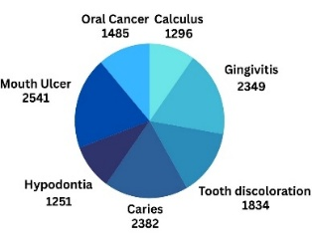
Fig. 1. Distribution of classes in the Oral Disease dataset.
  - Framework
The model accepts two modalities of input (image of the affected area, symptoms in the form of textual descriptions). The inputs are processed by their respective algorithms. The final prediction is made by evaluating the confidence scores of the algorithms using decision level fusion.
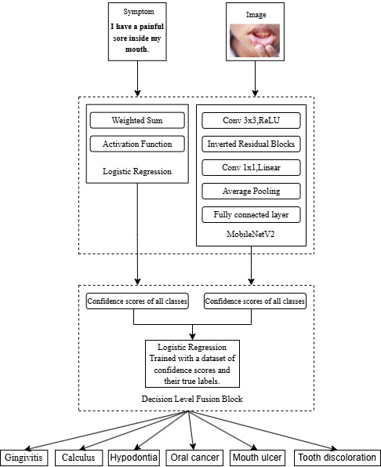
Fig. 2. Proposed framework for multi-modal classification.
  - Symptom classification model
The symptoms (textual descriptions) are converted into numerical features using vectorizer. The feature vector is passed to trained logistic regression model. Numerical output produced by the model is decoded and converted to human-readable disease label. Confidence scores of all the classes are captured for further evaluation.
  - Image classification model
For image classification, transfer learning using a pre-trained Convolutional Neural Network (CNN) model is employed. Transfer learning is a technique that allows us to leverage pre-trained architectures and apply them to our own dataset. These pre-trained models have been trained on extensive general datasets. The proposed work uses the pre-trained MobileNetV2, which is a 53-layer deep CNN architecture. The same was utilized in [12] for oral disease detection achieved an average accuracy of 80%. The above layers help reduce number of parameters and computations without disturbing the model’s ability to capture complete features. Each layer plays a unique role in the architecture that balances the performance and efficiency of the model.
The initial convolution layer has 32 filters and a stride of 2 which takes a 224 x 224 image input size. The convolutional layer is followed by a series of inverted residual blocks, each of which has a specific number of inverted residual blocks. Final Convolution Layer consists of 1280 filters, and the size of the convolutional layer is 1x1. The final layer is a fully connected layer with SoftMax activation function, which helps in multi-class classification.

  - Decision Level Fusion Layer
The combinative predictions of the two algorithms are determined using Decision Level Fusion. For the final fusion layer, balanced dataset is constructed utilizing the confidence scores by both the image and symptom models, along with the true labels for each class, 200 samples are obtained for each illness category resulting in dataset size of 1400. The fusion Logistic Regression model is trained with the above dataset to predict the ultimate class of the disease.

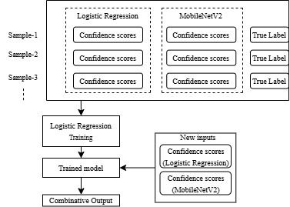
Fig. 3. Architecture of Decision Level Fusion.
- Results and Analysis
The traditional CNN algorithm was trained with 13,138 images of 7 classes. It had 5 convolutional layers, ReLU activation function, and a SoftMax function in the final layer. The model attained an average accuracy of 60%. Despite adjusting layers and parameters, the model could not surpass 65% accuracy, achieved on the 16th epoch.
As conventional CNN failed to attain satisfactory accuracy, pre-trained models like VGG16, ResNet 50, Inception, and Efficient Net were considered. The VGG16 model, trained with 2000 images per class and tested with 100 images per class, attained an average accuracy of 70%, with the highest being 72% at the 18th epoch. The InceptionV3 model achieved up to 72% accuracy, with its highest being 75% on the 24th epoch. The MobileNetV2 model from [12] achieved an average accuracy of 81%, with its highest being 84.14% on the 14th epoch, outperforming previous models. Consequently, MobileNetV2 was finalized for the image classification task.
Table 1. Models and their accuracies.
MODEL | AVERAGE ACCURACY
Traditional CNN | 60%
VGG16 | 70%
InceptionV3 | 72%
MobileNetV2 | 81%

The symptom classification model using Logistic Regression algorithm was trained with 150 different combinations of symptoms for each class, splitting the dataset into a train and a test set at a ratio of 4:1. The accuracy of the model is 97%.
The input to the model is in the form of English sentence which corresponds to the description of the oral disease seen in the mouth.
In the final decision-level fusion layer, the image of the disease and the corresponding symptom described by the patient are input to their respective models. Each model produces individual confidence scores, which are then combined and fed into the fusion layer for the final prediction.
Table 2. Results produced by the individual models.
Image based model (MobileNet V2) | Symptom based model (Logistic Regression)
  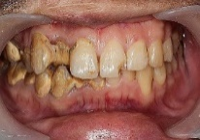 | Gingivitis: 0.5836  Calculus: 0.4053  Tooth Discoloration: 0.1775  Hypodontia: 0.0844
  I am experiencing a constant sour taste in my mouth. | Oral cancer: 0.3407  Calculus: 0.3740  Tooth Discoloration:  0.1143
  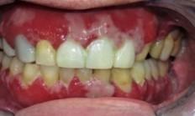 | Gingivitis:0.7512  Calculus: 0.1084  Oral Cancer: 0.0613  Hypodontia:0.0352
  I have been experiencing persistent bad breath while my gums are bleeding when brushing. (Gingivitis) | Gingivitis: 0.8371  Calculus: 0.0630  Mouth Ulcer: 0.0156  Hypodontia: 0.0124
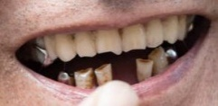  Hypodontia: 0.9529  Tooth Discoloration:0.1210  Oral Cancer:0.013
  I have significant gap in the frontal part of my teeth | Hypodontia: 0.240  Calculus: 0.1318  Oral Cancer:0.1223  Caries: 0.1049
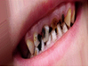
  Caries:0.6794
  Tooth Discoloration: 0.1775
  Hypodontia:0.084
  My teeth has turned to black and I get bad smell from my mouth | Tooth Discoloration: 0.4669  Hypodontia: 0.1134  Caries: 0.0576
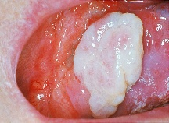
  Gingivitis:0.6508
  OralCancer:0.1816
  Calculus: 0.1555
  There is a white lump in my mouth which makes difficulty in swallowing | Oral cancer: 0.6751  Caries: 0.0807  Calculus: 0.0461
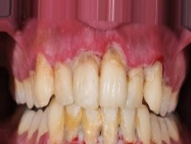
  Gingivitis: 0.5122
  Calculus:0.4279
  Tooth Discoloration: 0.0388
  My teeth colour has turned yellow and there are yellow deposits near the gums. | Calculus: 0.3798  Tooth Discoloration: 0.2433  Hypodontia: 0.1153
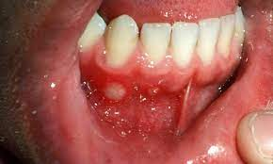
  Oral cancer: 0.3303
  Gingivitis: 0.2748
  Mouth Ulcer: 0.1947
  I have a painful sore on the gums | Mouth Ulcer: 0.3925  Gingivitis: 0.2505  Oral cancer: 0.0925

Table 2 presents results using only the affected area image and corresponding symptoms. Over 1000 images per class were evaluated, with confidence scores stored in a CSV file. Analysis showed 40% of predictions were clearly accurate with dominant confidence scores, 40% had borderline confidence (0.3-0.6) with multiple classes showing significant scores, and 20% were incorrect. Classes like Hypodontia, Caries, and Gingivitis achieved around 90% accuracy, while Tooth Discoloration, Calculus, Oral Cancer, and Mouth Ulcer reached approximately 70%. The same methodology was applied to text-based symptom analysis. The table highlights representative examples from the results.
Table 3. Results produced by multi modal fusion
Decision level fused model (image and symptom as input) | Decision level fused model (image and symptom as input)
  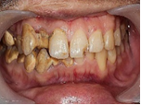  My gums appear swollen and red, and I can see hardened plaque at the gumline | Calculus: 0.5615  Gingivitis:0.3789  Tooth Discoloration: 0.0142
  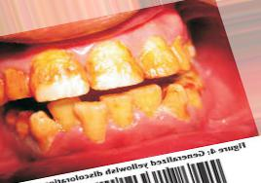  My teeth have developed yellow stains despite regular brushing. | Tooth Discoloration: 0.9163  Caries: 0.0315  Calculus: 0.0146
  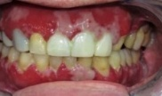  I have been experiencing persistent bad breath while my gums are bleeding when brushing. | Gingivitis: 0.9558  Calculus: 0.0303  Oral cancer: 0.0044
  My teeth has turned to black and I get bad smell from my mouth | Caries: 0.6733  Tooth Discoloration: 0.2794  Hypodontia: 0.0120
 | Oral Cancer:0.768  Gingivitis:0.1134  Calculus: 0.0022
  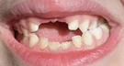  I was born missing  several teeth, which  has affected my  ability to chew  properly. | Hypodontia: 0.9908  Tooth Discoloration: 0.0060  Mouth Ulcer: 0.0012
  I have a persistent sore in my mouth that doesn’t heal.
  I was born missing several teeth, which has affected my ability to chew properly. | Mouth Ulcer: 0.4328  Oral cancer: 0.2062  Gingivitis: 0.1695
  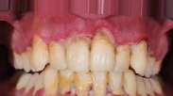  My teeth colour has turned yellow and there are yellow deposits near the gums. | Calculus: 0.7327  Gingivitis: 0.1319  Tooth Discoloration: 0.0592

Table 3 presents the results of the decision-level fusion model, where both the affected area image and corresponding symptom description are input. Unlike individual models processing either image or text alone, this fusion model evaluates both modalities to generate confidence scores. The fusion model often produced more accurate results compared to individual models using the same image-text pair. This approach enhances reliability and patient trust, considering both visual evidence and verbal symptoms. The model was tested on over 500 image-symptom pairs, with approximately 70% of predictions showing strong confidence (high dominance in the correct class), and 20% falling into an intermediate confidence range (0.5–0.6) for the correct label. Notably, even when both the image-based Mobile Net V2 model and symptom-based Logistic Regression model failed individually, the fusion model succeeded in generating the correct prediction highlighting the robustness and effectiveness of multimodal decision fusion.
- Conclusion
The proposed framework has presented a novel method for detecting oral diseases using a multimodal approach and improved accessibility to oral healthcare. The study leveraged decision level fusion mechanism to enhance the diagnostic accuracy.

  - Future work
Future work focuses on leveraging the proposed framework for various other diseases. Enhanced accessibility in remote and resource-constrained regions can be rendered by creating an online website that integrates a user-friendly interface and real-time symptom analysis. Additionally, user engagement can be improved by incorporating a chatbot for interactive consultations and personalized recommendations. Ensuring diversity in data collection can enhance the model’s robustness and generalizability across different factors.

References
- Anantharaman, R., Velazquez, M., Lee, Y.: Utilizing Mask R-CNN for Detection and Segmentation of Oral Diseases. In: 2018 IEEE International Conference on Bioinformatics and Biomedicine (BIBM), pp. 2197–2202 (2018). https://doi.org/10.1109/BIBM.2018.8621112
- Chicco, D., Lovejoy, C.A., Oneto, L.: A Machine Learning Analysis of Health Records of Patients with Chronic Kidney Disease at Risk of Cardiovascular Disease. IEEE Access 9, 165132–165143 (2021). https://doi.org/10.1109/ACCESS.2021.3135536
- Hema, P., Darbha, A., Sunny, N., Naganjani, R.V.: Disease Prediction Using Symptoms Based on Machine Learning Algorithms and Natural Language Processing. In: International Conference on Artificial Intelligence and Knowledge Discovery in Concurrent Engineering (ICECONF), pp. 1–6 (2023). https://doi.org/10.1109/ICECONF57872.2023.10084030
- Jaidee, E., Theppitak, S., Suebnukarn, S., Wongsapai, M., Ittichaicharoen, J., Wuttisarnwattana, P., Suthachai, T., Warin, K.: Oral Tissue Detection in Photographic Images Using Deep Learning Technology. In: Proceedings of the 27th International Computer Science and Engineering Conference (ICSEC), pp. 1–12 (2023). https://doi.org/10.1109/ICSEC56509.2023.10329780
- Jain, N., Dutt, U., Radenkov, I., Jain, S.: WHO's Global Oral Health Status Report 2022: Actions, Discussion, and Implementation. Oral Diseases (2023). https://doi.org/10.1111/odi.14516

- Kawata, S., Takahashi, S., Hagiwara, T.: Visibility Level Estimation in Winter CCTV Images Based on Decision Level Fusion Using Logistic Regression. In: 2020 IEEE 9th Global Conference on Consumer Electronics (GCCE), pp. 640–644 (2020). https://doi.org/10.1109/GCCE50665.2020.9291922
- Manodeep Ray.: Oral Cancer Dataset. Kaggle. https://www.kaggle.com/datasets/raymanodeep/oral-cancer-v2-part-1
- Sajid, S.: Oral Disease Dataset. Kaggle. https://www.kaggle.com/datasets/salmansajid05/oral-diseases
- Rohith, S., Reddy, K.J., Kalaiselvi, K.: A Symptom-Based Disease Diagnosis: A Pre-Classification ML Approach. In: 2024 4th International Conference on Pervasive Computing and Social Networking (ICPCSN) (2024). https://doi.org/10.1109/ICPCSN59994.2024.10607702
- Shang, W., Li, Y., Li, Z.: Identification of Common Oral Disease Lesions Based on U-Net. In: 2021 IEEE 3rd International Conference on Frontiers Technology of Information and Computer (ICFTIC), pp. 194–198 (2021). https://doi.org/10.1109/ICFTIC54302.2021.9647420
- Swetha, S., Kamali, P., Swathi, B., Vanithamani, R., Karolinekersin, E.: Oral Disease Detection Using Neural Network. In: 2020 9th International Conference System Modeling and Advancement in Research Trends (SMART) (2020). https://doi.org/10.1109/SMART50582.2020.9337094
- Teo, A.H.A., Goh, C.P.: Oral Disease Image Detection System Using Transfer Learning. In: 2024 IEEE 3rd International Conference on Digital Transformation and Applications (ICDXA), pp. 194–196 (2024). https://doi.org/10.1109/ICDXA59621.2024.10470514

